50th ANNIVERSAIRY OF THE NATIONAL YOUTH DAY
THEME: YOUTH, CITIZENSHIP AND THE FIGHT AGAINST INSECURITY FOR AN EMERGENT CAMEROON
There’s nothing as encouraging as watching youths demonstrate their love for their country through their activities. The 50th Anniversary of the National Youth Day in Cameroon, celebrated at CEBER by the students and members of the administration was a huge success filled with amusement. Starting already from Friday the 5th February on the National Bilingualism Day, there was an expression of patriotism in through songs, poems, sketches and debates.
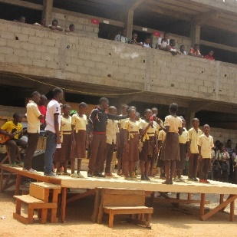
For more than two weeks, the Bilingualism Club, worked on their activities to present on the 5th of February. They had poems, sketches, debates and songs, all focusing on the importance of Bilingualism.

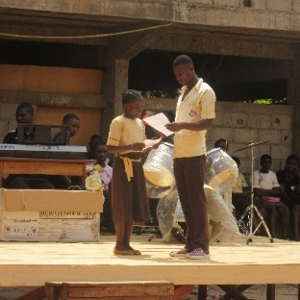
A little ten-year-old Francophone girl, wrote a little poem titled “My Mother” in English, and read it to the audience.
Who sits and watch my head when I sleep in my cradle bed?
On my cheeks sweet kisses from my mother.
When pain and sickness makes me cry,
Who gaze upon my weary eyes,
For fear of pain that I should die?
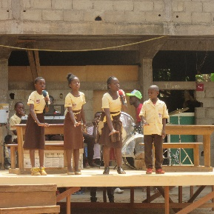
No one else but my mother.

Her personal initiative is a great encouragement to CEBER and the general public of Cameroon, for it illuminates on our objectives, to develop students who are able to express themselves in whatever language they find themselves.
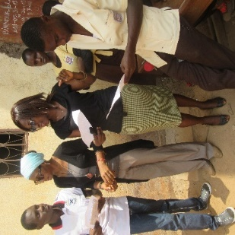
Ms Ngasseu was the main coordinator for the club, and together with her, we edited the student’s research, their sketches, poems, and helped with their pronunciations. The students took charge of their day’s activities as impresarios, in both English and French. It was very impressive and encouraging to see them practicing the language they continuously learn in class.

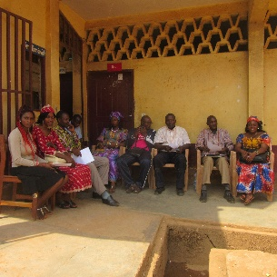
Members of the administration came out in their numbers to show support to the students in their different activities. We were especially honoured by the overseer of all student activities, Mr. Mougoue, Mrs. Nkompawa Jeanne, the Senior Discipline Master, Mr. Ondigui, the Principal, Mr. Youssa Tchamango, and the Vice Principal, Mr. Asonganyi Dominic and Ms. Engawpi Solange.

Fast forward to the Youth week, students carried out different activities such as marching, competing in other schools and presenting their talents in different youth week activities in town. On Saturday, we drew up the event programmes with the different clubs. It was very challenging to work without all the clubs and without the electricity. This thus increased our workload on Monday during the rehearsal. Nonetheless, the rehearsals went on well on Monday, and on Tuesday we began the main event at 11:30 a.m. The theme for the Youth Day: Youth, Citizenship, and the Fight Against Insecurity for an Emergent Cameroon, gave voice to the students as demonstrated in their different presentations. They expressed their talents with great energy, without fear of intimidation.
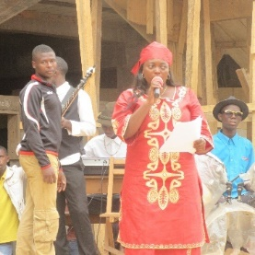
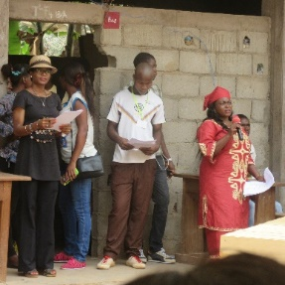
The day began with a word of prayer through a worship song “El Shadai”, led by Ms. Engawpi, accompanied by Alliami Bobbo, a student in Premiere F3.

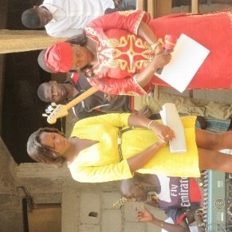
After the prayer, the Student Cooperative President gave a short speech and called on the spectators to have a moment of silence in memory of all the families who had lost their loved ones last year due to Boko Haram’s attacks.

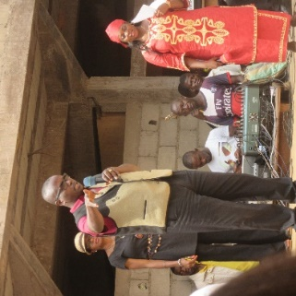
This was followed by a short speech from the Principal, Mr. Youssa Tchamango, who shared words of wisdom once again with the public. He encouraged the spectators to appreciate the talents students have and also to remain truthful. From within oneself, we should learn to admit our faults/mistakes and not place the blame on others.

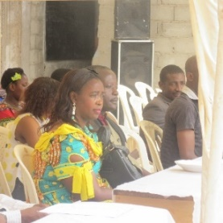
The founder’s wife, Mrs. Jeanne Nkompawa, graced us with her presence and it really encouraged the students. She danced and supported the students, encouraging them to continue developing their unique talents.

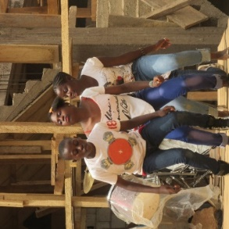
CEBER has upcoming dancers. These children can move their bodies. It is very encouraging to see them outside of the classrooms, and to appreciate the different talents they are good at. Our prayer and wish is for these students to place as much efforts in their studies, as they do in art.

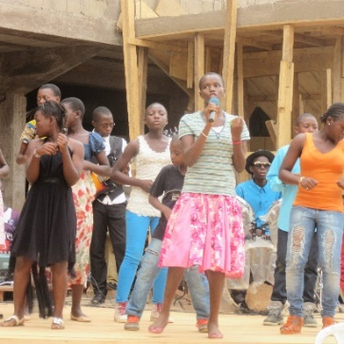
Nous sommes une génération Choisie, appelé pour son excellence. Tous que j’ai Dieu me la donnée , je sais qui je suis. Je marche dans la puissance, je marche en miracle, je vie une vie de faveur, je sais qui je suis/
We are a chosen generation, called on to show his excellence. All I require the Lord, God has given me, I know who I am. I walk in power, I walk in miracles, I live a life of favour, I know who I am.
This was a song these children sang believing in the message it brought to them. Being a part of their group and working with them brought me so much joy. The message that this song had was so unique, because it was sung by the form ones and 6eme students.
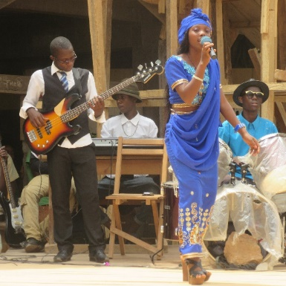
This beautiful young lady had such a beautiful voice that drew crowds. We were really proud of the students and their hard work in extra curriculum activities. You never know what’s hiding in the cupboard, till you open to see its contents. The students in CEBER have wonderful gifts, which should be encouraged.

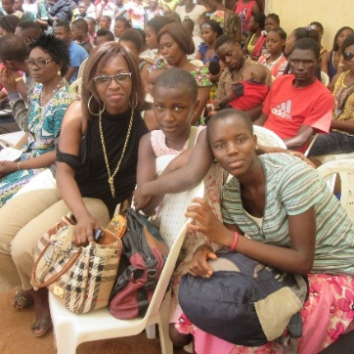
We had beautiful spectators, who were very encouraging. Although we had obstacles with the electricity going off for almost an hour, the spectators stayed seated as children continually displayed their talents.

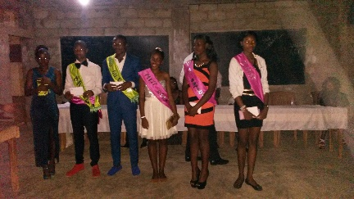
The Gala didn’t start till 9:30 pm, but we were able to finish giving the student awards by 11 pm. The different clubs received awards, and Miss Master was crowned, demonstrating the different talents in CEBER. and the dance floor got liberated.

To that we were able to say Happy 50th Anniversary of the National Day to all the CEBER students and the youths in Cameroon.

